React JS Application

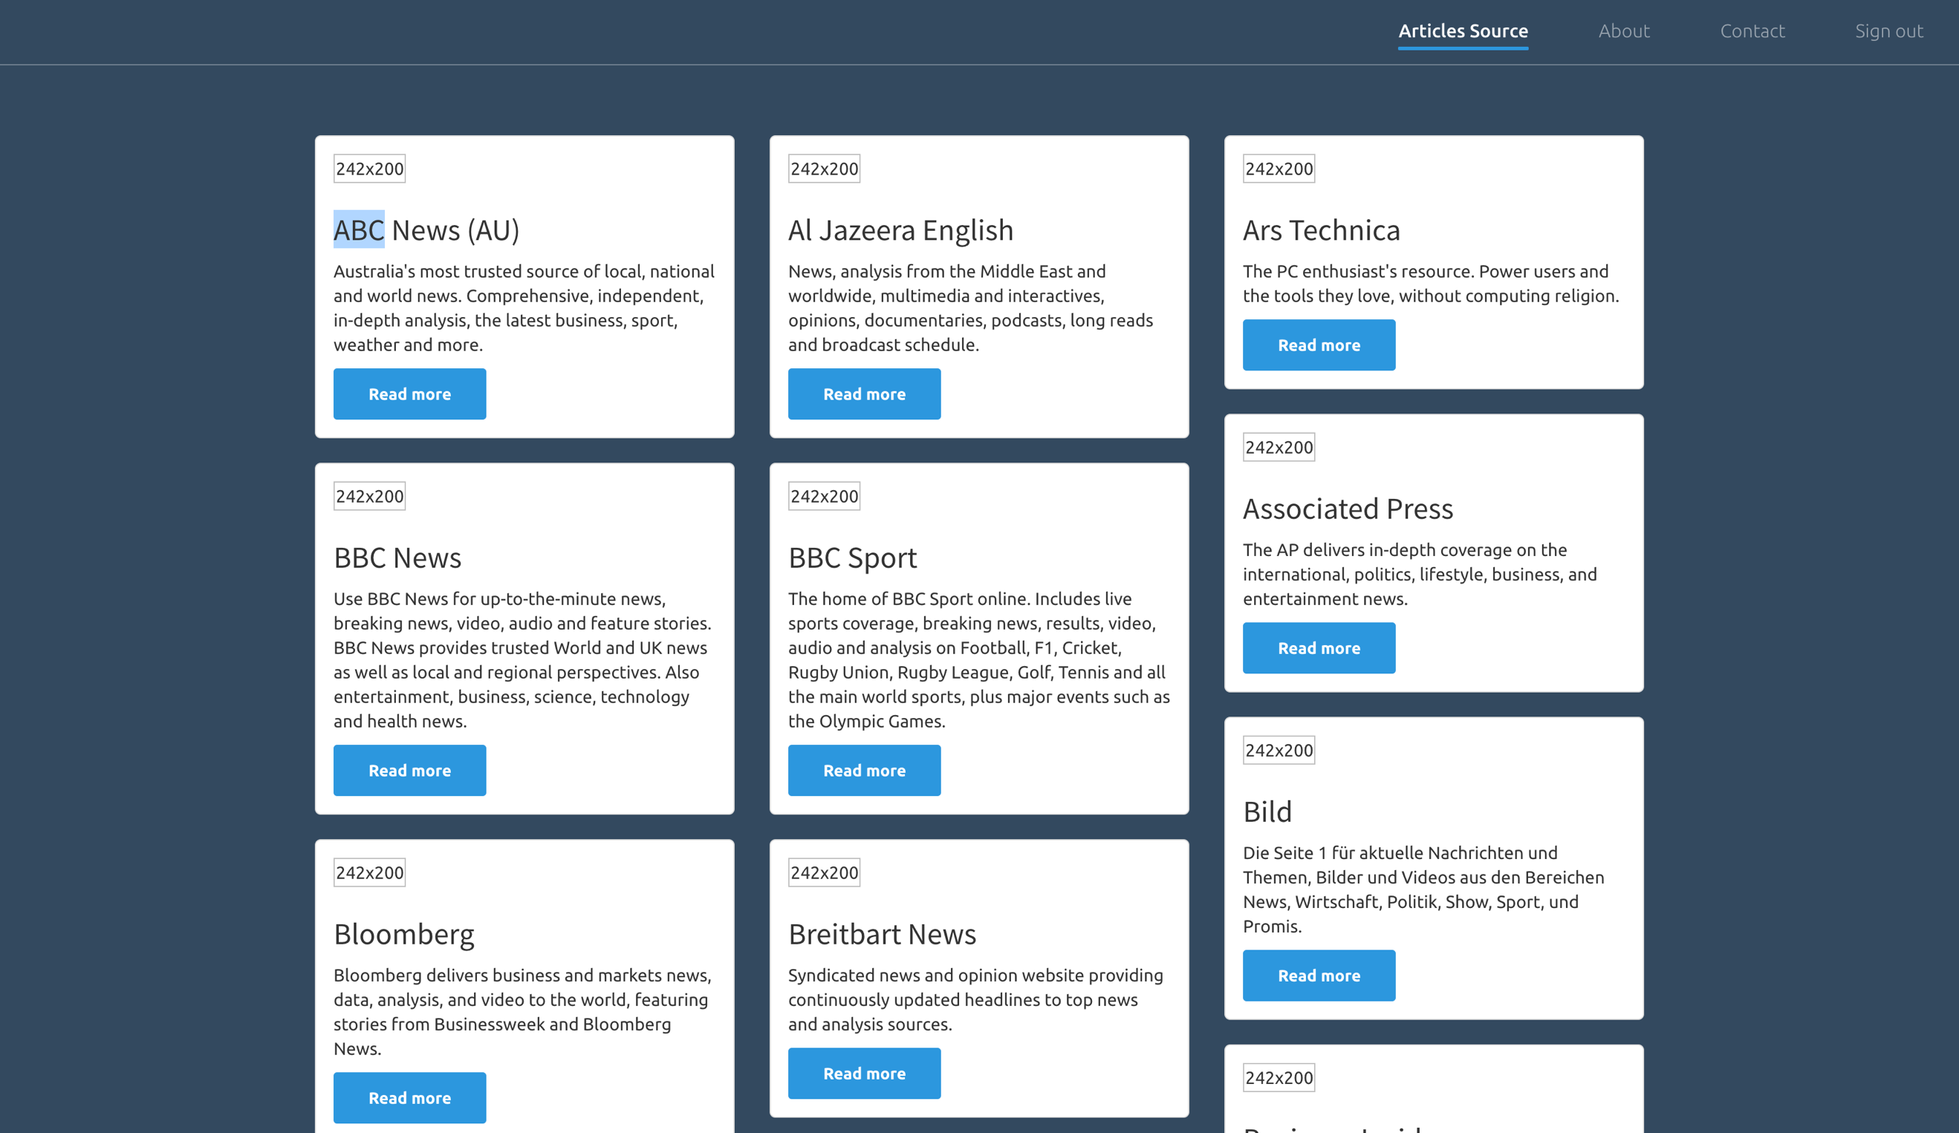

The given wireframe is for a News Listing page.

You are expected to create an React JS(Redux) Application for the same.  
  
Requirements:   
  
1. All the Visible Data should be rendered from External API which is from this website <https://newsapi.org/>  
  
2. Create One more screen for News Details page which should look like below wireframe  
  


3. Use Routers to Navigate the screens.

4. Do very simple styling with Mobile Responsive.